DTC Communication Guide for ADP

This is a guide for District Test Coordinator (DTC) to communicate with staff regarding important dates for the Alaska Developmental Profile.

Contents

Alaska Developmental Profile Timeline 1

ADP Observation Window 1

Email Template for Principals 1

Email Template for New or Returning Teachers 2

ADP Recording Window Opening 2

Email Template for Principals 2

Email Templates for Teachers 2

ADP Deadline Approaching 3

Identifying Schools or Teachers 3

Email template to Principals 4

Email template to Teachers 4

# Alaska Developmental Profile Timeline

The Alaska Developmental Profile (ADP) is required in the fall of each year as part of the statewide comprehensive system of student assessments, [4 AAC 06.712](http://www.akleg.gov/basis/aac.asp#4.06.712). The ADP documents what students know and can do as they begin their formal education at school. This profile is required for all kindergarten students and any first-grade student who did not attend kindergarten.

Teachers may begin conducting observations of students starting their first day of school or beforehand through home-visits or classroom visits with the child’s family. Teachers are also encouraged to talk to the student’s previous providers, such as preschool, childcare, or Head Start program.

# ADP Observation Window

Starting in 2023-2024, DEED has provided a recommended observation window to stress how important it is that teachers are able to record student’s skills as they enter kindergarten rather than their skills a couple months into kindergarten.

DEED has developed email templates to send out to school principals and/or teachers. Emails to school principals can contain the template for emailing teachers if the principal is new.

## Email Template for Principals

Dear [Insert Principal Name],

The Alaska Developmental Profile (ADP) recording window opens on (Insert Date), please work with new teachers to ensure that they know the timelines for ADP. The observation window is now open and teachers should be encouraged to start conducting observations at the beginning of the year in preparation for when the website opens for recording the results.

## Email Template for New or Returning Teachers

Dear [Insert Teacher Name],

As the school year begins, this email serves as a reminder about the Alaska Developmental Profile (ADP) that will be due November 1st. The ADP is an observation-based assessment used to document the skills and behaviors that students are displaying at the beginning of their school experience. It is required for ALL kindergarten students and any first grade student who did not attend kindergarten.

The ADP measures 13 goals over 5 different domains. More information and resources about the specific goals can be found on the [ADP webpage](https://education.alaska.gov/assessments/developmental).

The recording site for inputting scores will not be open until [Insert Date]. Please begin observing your students and collecting relevant background information from their families about whether they attended preschool. Teachers are encouraged to talk to students’ families and previous preschool providers about what the skills students are able to demonstrate in regard to the 13 ADP goals.

Teachers may carry the [ADP Individual Protocol](https://education.alaska.gov/tls/Assessments/DevelopmentalProfile/ADP-Protocolstudent,w-scoring%20guide.docx) checklist when meeting with families during home visits or classroom visits at the beginning of the year or print out [ADP Group Protocol Checklist](https://education.alaska.gov/tls/Assessments/DevelopmentalProfile/ADP_Protocol_for_Group.docx) for use during recess or group activities.

# ADP Recording Window Opening

It is recommended that in Early September before the ADP window opens that DTCs email new and returning staff to inform them of these important upcoming dates and tasks.   
  
Please Note: This is around the same time that DTCs should plan to upload the student lists so that teachers will be able to “Pick Students” once the website becomes available to them. More information on the DTC upload process can be found on the ADP Website under “DTC Resources.”

## Email Template for Principals

Dear [Insert Principal Name],

The Alaska Developmental Profile recording window opens on [Insert Date]. Please check-in with your teachers and remind them that their ratings for students will be due by November 1st.

Please reach out to your District Test Coordinator to check-in on your teachers’ progress.

## Email Templates for Teachers

Dear [Insert Teacher Name],

The Alaska Developmental Profile (ADP) recording window opened on [Insert Date], please start inputting your ratings into the website. All ratings must be entered by November 1st, but you are encouraged to get them in before that.

Login link: <https://education.alaska.gov/devprof/Home>

**Username**: first initial + full last name (for example, Jane Doe would be jdoe). This includes any special symbols like ‘ – or spaces.   
  
**Password:** Your password is your full ATI (Alaska Teacher Identifier number) plus the last 4 of your social security number with NO SPACES.

*For example, if someone has an ATI of 12345 and a social security number of 987-65-4321, they would enter 123454321*

Your ATI number can be manually looked up: <https://teachak.alaska.gov/public/licensesearch>

or you can call Teacher Certification at 907-465-2831.

For more information and resources on the Alaska Developmental profile, please see “Teacher Resources” on the main ADP website: <https://education.alaska.gov/assessments/developmental>

# ADP Deadline Approaching

It is recommended that up to 2 weeks before the ADP window closes that DTCs email staff who have partials or large numbers of children who have either been picked but not profiled or not picked at all.

## Identifying Schools or Teachers

Log into the [DTC Portal](https://education.alaska.gov/DevProf/Home/DistrictLogin)

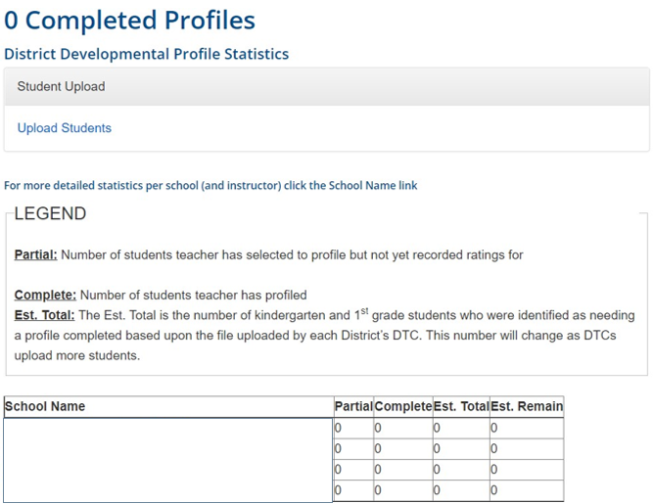

You can identify schools with large numbers of Partials or Estimated remaining and email the principal to contact the teachers.

To identify the teachers, click on the school name and it will tell you which teachers have students remaining in the “Estimated Remaining” column.

## Email template to Principals

Dear [Insert Principal Name],

As a reminder, the Alaska Developmental Profile is required under [4 AAC 06.712](http://www.akleg.gov/basis/aac.asp#4.06.712). The window for teachers to record their student’s developmental profile ratings is closing on November 1st.

Please reach out to the following teachers:

## Email template to Teachers

Dear [Insert Teacher Name],

As a reminder, the Alaska Developmental Profile is required under [4 AAC 06.712](http://www.akleg.gov/basis/aac.asp#4.06.712). The deadline for teachers to record their student’s developmental profiles is closing on November 1st. Please log into the website to input your ratings at <https://education.alaska.gov/devprof/Home>

If you need additional help or resources, please go to <https://education.alaska.gov/assessments/developmental>